District Contacts

Jenny Shumar - 714-433-3474
Program Specialist Pupil Support Services District McKinney-Vento Liaison

Heidi Cisneros - 714-433-3484
Executive Director Pupil Support Services

Orange County Department of Education

Jeanne Awrey- 714-966-4093
Manager-Student Support Services

State Coordinator

Leanne M. Wheeler- 866-856-8214
State Program Coordinator



Santa Ana Unified School District

Student Support Services Division
Pupil Support Services Department

McKinney-Vento
Homeless Children and Youth Education Assistance Act Student and Parent Manual

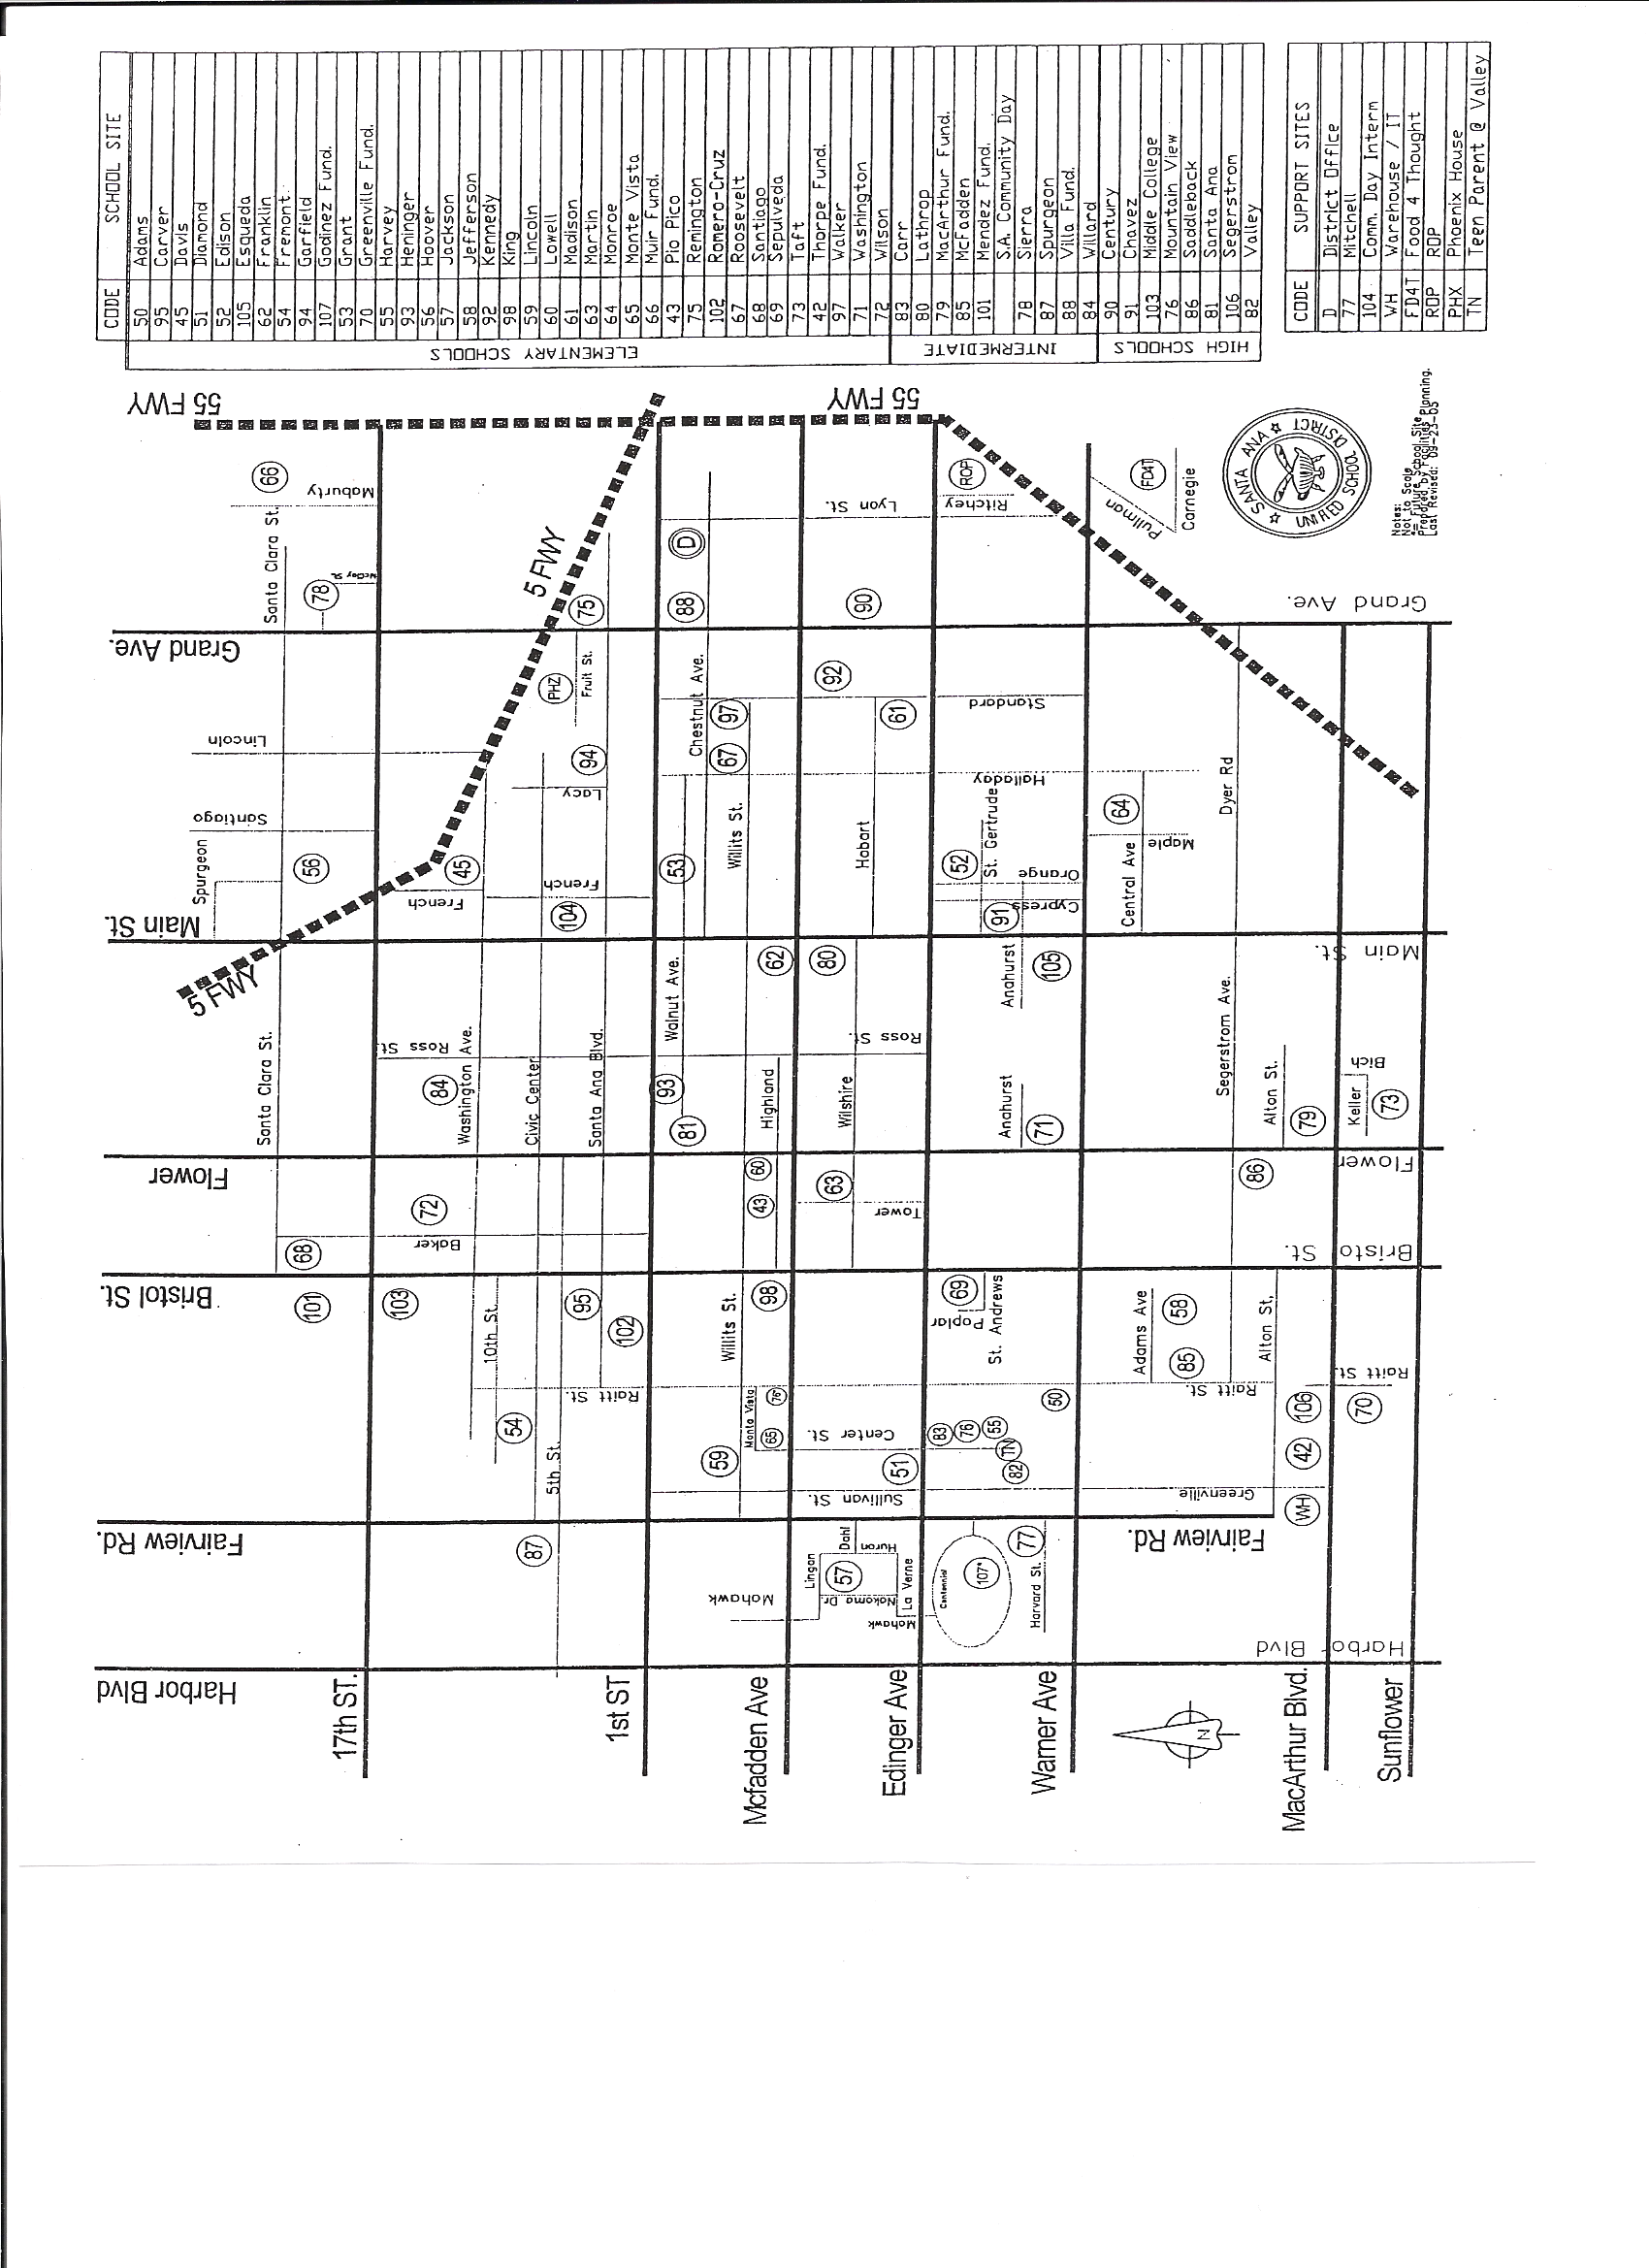

McKinney-Vento

Homeless Children and Youth
Education Assistance Act

Student and Parent Manual

Table of Contents

Introduction P. 1

Defining Homelessness P. 2

Student's Educational Rights P.3

Services for Students P.4

School Choice P.5

Enrollment Procedures and Practices P.6

School Site Assistance P.7

Introduction

On January 8, 2001, President George Bush signed into law the "No Child Left Behind" (NCLB) Act. This Act has ten different parts called "titles." The McKinney-Vento Homeless Children and Youth Education Assistance Act, under Title X, Part C of No Child Left Behind, deals with the education of homeless children and youth.

Santa Ana Unified School District is determined to assist all our homeless students according to these new guidelines. We are committed to ensure that all our identified homeless students receive the free and appropriate public education to which they are entitled.

1

Special Schools and Programs (714)

REACH Academy 431-1815

Independent Study Program 565-5400

Phoenix House 953-9373

CAL Safe Program 431-7540

Mitchell Child Development Ctr. 430-5600

Middle College High School 953-3900

Head Start 431-7576

State Pre-School 431-7540

10

Santa Ana School District Phone Directory

Intermediate Schools (714)

ALA 480-4300
Carr 480-4100
Lathrop 567-3300
MacArthur 568-7700
McFadden 479-4000
Méndez 972-7800
Sierra 567-3500
Spurgeon 480-2200
Villa 558-5100
Willard 480-4800
High Schools (714)

Century 568-7000
Chávez 430-5700
Godinez 433-6600
Lorin Griset 648-2900
Saddleback 569-6300
Santa Ana 567-4900
Segerstrom 241-5000
Valley 241-6410
9
Defining Homelessness

Under the "No Child Left Behind" regulatory mandate, a person fits the federal government's legal definition of homeless based on McKinney-Vento who:

- Lacks a regular, fixed, and adequate nighttime residence (substandard housing);

- Is sharing housing due to economic struggles (doubled-up and not the name on the lease or rental agreement);

- Is living in a shelter, hotel or motel;

- Sleeps in any public place not designed for sleeping (cars, parks);

- Is an unaccompanied youth; (a child or youth not in the physical custody of their parent or guardian)

- Is a migrant education child who qualifies under any of the above situations.

2
Student’s Educational Rights
Under NCLB of the McKinney-Vento Act, every school age student has the right to a free public school Education and to:

- Go to school, no matter where they live or how long they have lived there;

- Continue in the school they attended when they became homeless or the current neighborhood school, if it is the choice and is in their best interest;

- Receive transportation to the school they attended when the family became homeless, if it is out of the area where they are currently living. Transportation must be requested;

- Attend school in the pathway of matriculation when changing grade spans if requested;

- Participate in special programs and services at school with children who are not homeless;

- Enroll in the neighborhood school without giving proof of residency;

- Register and attend classes while the school arranges for the transfer of school and immunization records or any other documents required for enrollment;

- Remain in school and attend classes while disputes over enrollment are being resolved.

3
Santa Ana Unified School District Phone Directory
Elementary Schools (714)

Adams 967-3100 Lincoln 972-6200
ALA 480-4300 Lowell 972-6300
Carver 564-2000 Madison 972-6400
Davis 564-2200 Martin 480-8000
Diamond 480-8100 Monroe 569-9700
Edison 479-6900 Monte Vista 564-8500
Esqueda 431-1500 Muir 972-6700
Franklin 564-2900 Pio Pico 972-7500
Fremont 972-4300 Romero-Cruz 564-8000
Garfield 972-5300 Roosevelt 564-1200
Greenville 558-3400 Santiago 564-8400
Harvey 479-4200 Sepulveda 433-6500
Heninger 953-3800 Taft/DHH 550-1400
Heroes 568-9600 Thorpe 430-5800
Hoover 564-2100 Walker 647-2800
Jackson 569-3500 Washington 445-5100
Jefferson 285-3700 Wilson 564-8100
Kennedy 972-5700
King 972-6000

8

School Site Assistance

After registering or enrolling your student, the school site staff will ensure the process of placement in the classroom goes smoothly.

Ask to speak to the McKinney-Vento site designee so that the following may occur:

- Immunization clearance assistance;

- Backpack and school supplies can be provided if needed;

- Assessment of the need for transportation or school uniforms;

- School schedule and additional academic support information should be provided.

7

Services for Students

Every student identified as homeless is entitled to receive a free and appropriate public education. They are encouraged and supported to complete a high school education and prepared for higher education and/or careers.

General Education:
Homeless students will receive the same core curriculum and experiences that students not experiencing homelessness receive.

Special Education:
Homeless students will have expedited evaluations and receive services as needed.

Supplementary Services:
Homeless students may participate in after-school activities and programs in which students not facing homelessness participate.

4

School Choice

Multiple moves could occur in one academic school year. Finding a new school every time you move is both stressful and time consuming. Due to this transient issue, homeless families may request one of the following:

- To attend the school the student attended when he/she first became homeless;

or

- To attend the current neighborhood school where he/she is residing.

The school choice request is to be made by the parent/guardian/student and should take into consideration feasibility (what is in the best interest of the child, length of time to arrive and return home). District Designee may be consulted.

The Student Services Office at the Center Street Office will determine the qualification of transportation upon request.

5

Enrollment Practices and Procedures
Every student has the right to enroll, register, and attend classes that will lead to high school graduation. The following are steps to address when you register at the school.
Step 1:
Choose between the school attended when student became homeless or current neighborhood school. Consider the best educational interest of the student.
Step 2:
Present whatever required documentation you have to the registrar's office.

Step 3:
Ask to speak to the school's McKinney-Vento site designee to access referrals for community services.
Note:
If an enrollment dispute arises and the Administrative Regulations and Board Policies have been followed, the parent/guardian/student will receive written notification of the enrollment dispute in their primary language within a reasonable time and be referred to the District's McKinney-Vento Liaison for further action.

6

